4. Report Drafting Layer (Industry-Level Detail)
The Report Drafting Layer integrates a biomedical-specialized large language model (LLM) to generate structured, narrative draft reports from inputs provided by the AI Analysis Engine (e.g., highlighted findings, attention maps) and retained image metadata (e.g., modality, body part). This layer produces clinician-editable drafts in standard radiology formats (Technique, Findings, Impression), significantly reducing repetitive phrasing while preserving full professional accountability.
Implementation resides in /backend/reporting/ and /models/llm/, using Hugging Face Transformers for efficient inference and alignment with MHRA principles of transparency and human oversight.
Key Implementation Details
- Model Choice: BioGPT (Microsoft Research) or fine-tuned open alternatives (e.g., Llama-3-Bio or ClinicalCamel) – domain-specific for biomedical text generation, outperforming general LLMs on medical report tasks.
- Input Prompt Engineering:
  - Structured prompt: Combine image description (from ViT findings), heatmap-derived key regions (e.g., "consolidation in right lower zone"), and metadata (e.g., "Chest PA view").
  - Example prompt template: "Generate a structured radiology report with sections: Technique, Findings, Impression. Image shows [ViT findings]. Highlighted areas: [regions]."
- Output Format: Structured text (markdown or JSON) with clear sections; optional RSNA radiology report templates.
- Mandatory Human Verification:
  - UI enforcement: Draft flagged with watermark/banner "AI-Assisted Draft – Mandatory Clinical Review and Approval Required".
  - Edit tracking: Diff view showing AI suggestions vs clinician changes.
  - No auto-export to PACS/RIS without explicit sign-off.
- Why This Ensures Human-in-the-Loop and Accountability:
  - Aligns with UK guidelines (MHRA, RCR): AI assists but never diagnoses or finalizes reports.
  - Reduces cognitive burden (repetitive normal reports) while maintaining liability with the clinician.
Industry-Level Example Diagrams and Visuals
Figure 28: BioGPT architecture for biomedical text generation and mining (Domain-specific Transformer model reference.)
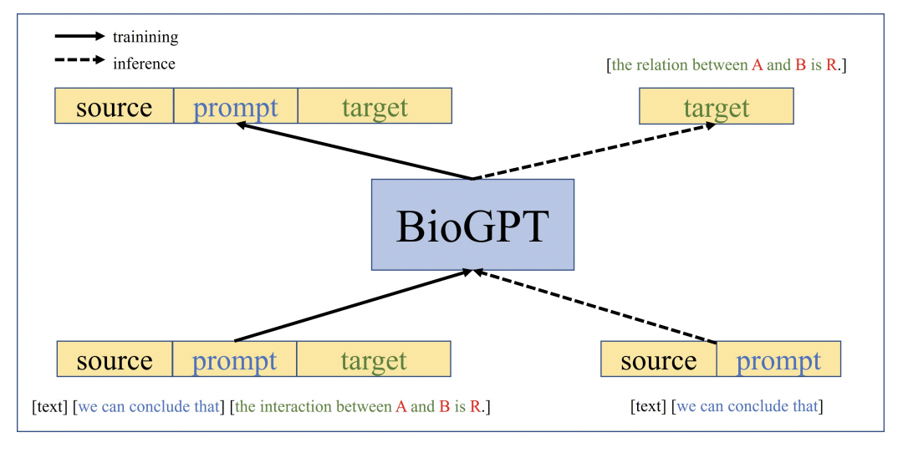
mlwires.com
BioGPT: generative pre-trained Transformer for biomedical text ...
Suggested filename: fig28-biogpt-architecture.pdf
Figure 29: Generative pipeline for multimodal medical report generation (End-to-end architecture from image to structured report.)
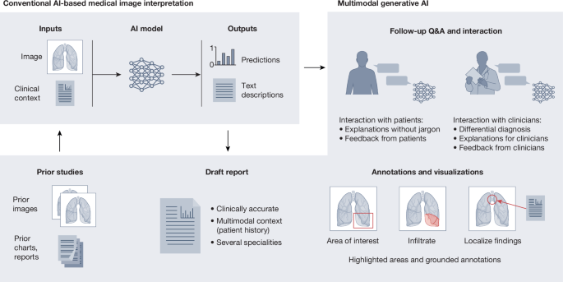
nature.com
Multimodal generative AI for medical image interpretation | Nature
Suggested filename: fig29-multimodal-report-pipeline.pdf
Figure 30: Graph-driven medical report generation workflow with knowledge guidance (Advanced LLM integration example.)
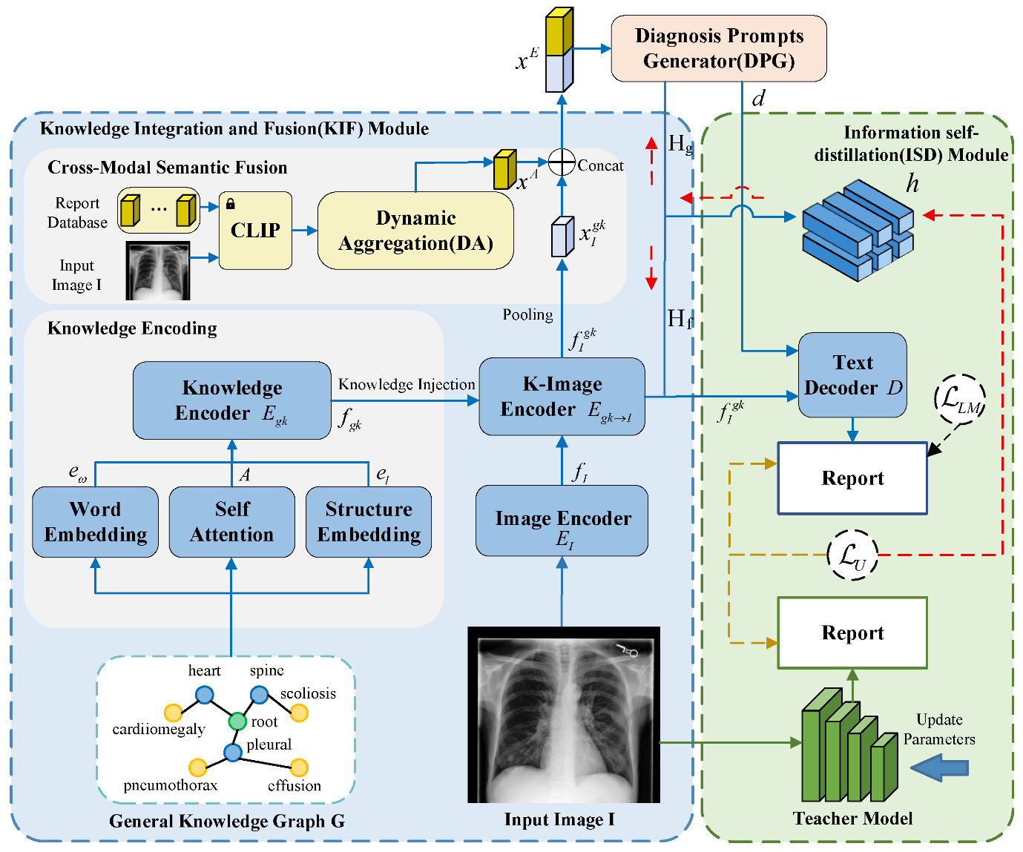
mdpi.com
Graph-Driven Medical Report Generation with Adaptive Knowledge ...
Suggested filename: fig30-graph-driven-report-generation.pdf
Figure 31: Example structured AI-generated radiology report (Findings and Impression sections) (Standard output format for drafts.)
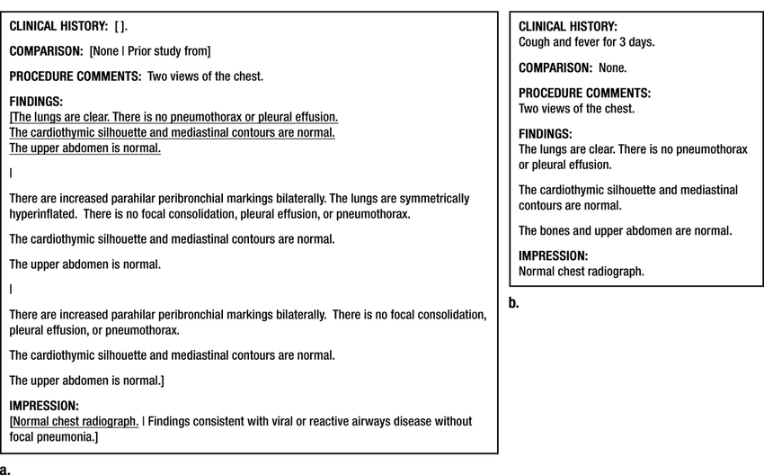
researchgate.net
a) Structured report example for a two-view radiograph. Brackets ...
Suggested filename: fig31-structured-report-example.pdf
Figure 32: Patient-centered generative AI radiology report output (Full report with technique, findings, impression.)
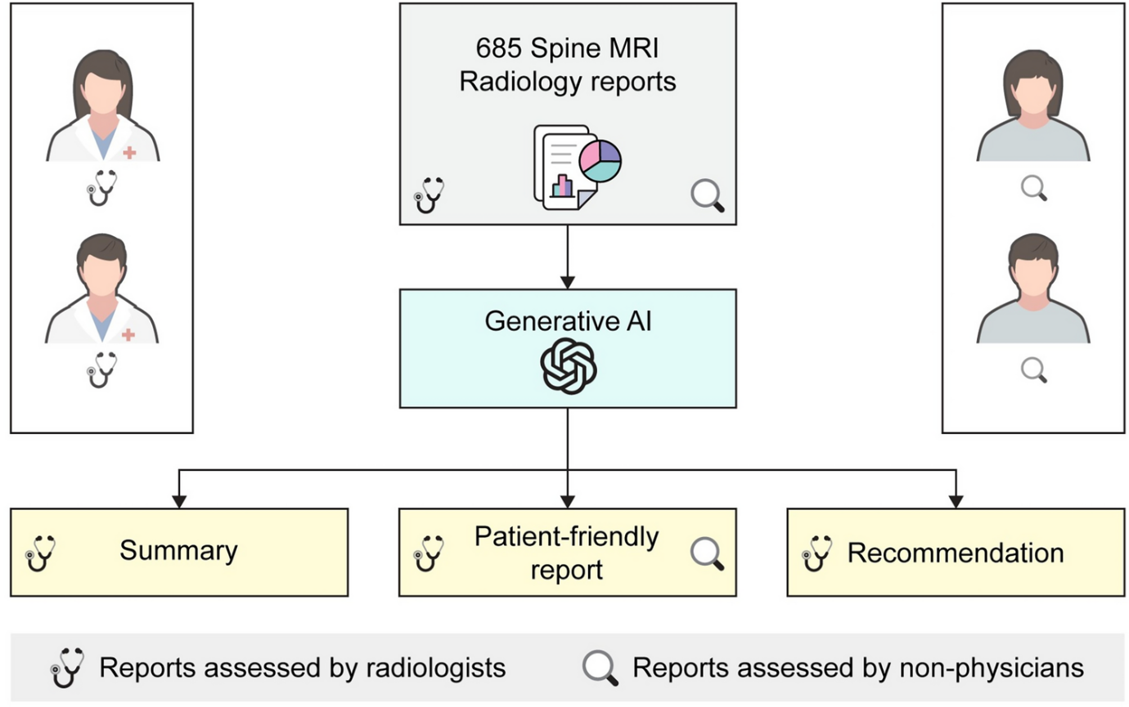
nature.com
Patient-centered radiology reports with generative artificial ...
Suggested filename: fig32-patient-centered-report.pdf
Figure 33: Chest X-ray with heatmap overlay and corresponding AI-generated report text (Direct input-to-output visualization.)
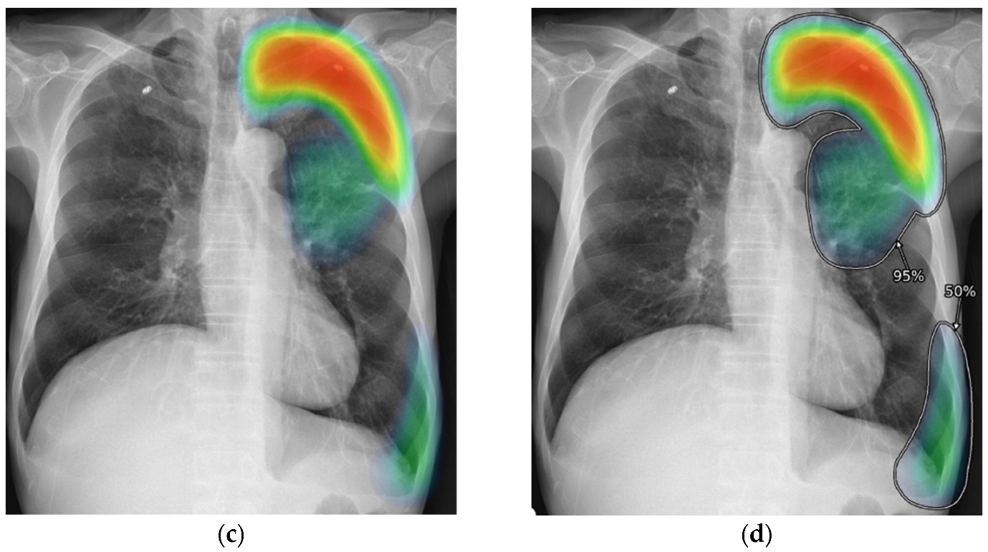
mdpi.com
Methods of Visualizing the Results of an Artificial-Intelligence ...
Suggested filename: fig33-heatmap-with-report.pdf
Figure 34: Additional example of AI visualization (heatmap) paired with report draft (Multiple cases showing findings translation.)
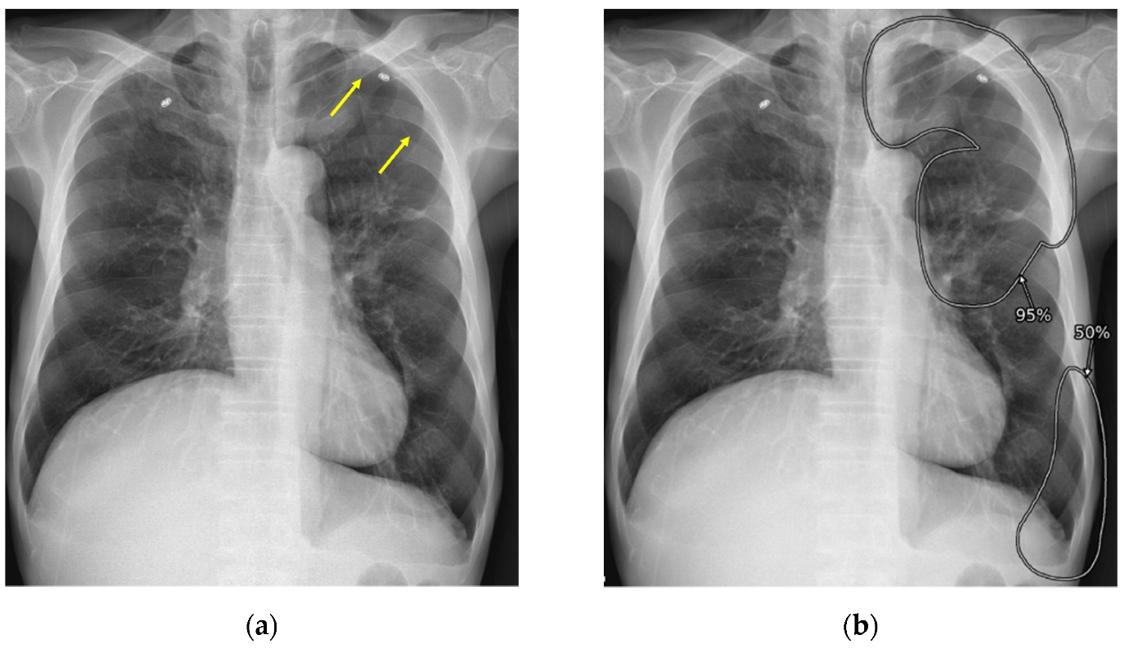
mdpi.com
Methods of Visualizing the Results of an Artificial-Intelligence ...
Suggested filename: fig34-multi-heatmap-report-examples.pdf
Figure 35: Human-in-the-loop AI feedback loop in radiology reporting (Emphasizes mandatory clinician review.)
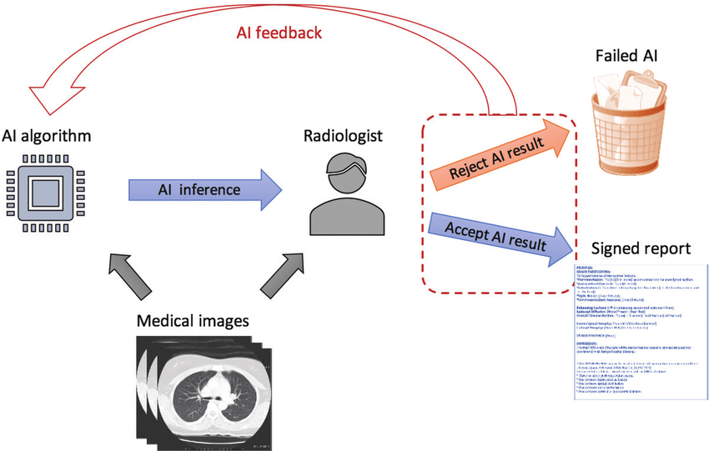
researchgate.net
Diagram illustrates the implementation of an artificial ...
Suggested filename: fig35-human-in-loop-workflow.pdf
Evidence Artefacts for Repository
- report_generator.py: Script with prompt templates and inference code.
- Sample anonymised inputs/outputs: /docs/samples/report_sample_01.txt (prompt + draft report).
- Screenshots: UI showing flagged AI draft and edit interface.
- Logs: Generation timestamps and token usage.
This layer completes the end-to-end assistance pipeline, demonstrating responsible generative AI that enhances efficiency while upholding clinical standards and accountability. Include evaluation notes (e.g., BLEU/ROUGE scores vs ground truth from public datasets) in docs for verifiability.

